Homework #6

1. What is the *root* of the tree?
   1. Yellow
2. What are the *leaves* of the tree?
   1. Magenta, Cyan, Orange, White, Gray, Brown
3. What are the *children* of the node *blue*?
   1. Black, White, Gray, Brown
4. What is the *parent* of the node *cyan*?
   1. Red
5. What nodes are on the *path* from the root to the node *orange*?
   1. Blue, Black
6. What is the *size* of the tree?
   1. 11
7. What is the *height* of the tree?
   1. 4
8. What are the *tags* in this XML document?
   1. WebServiceResponse, status, result, type, name, location, lat, lng, result, message
9. What are the *text* strings in this XML document?
   1. OK, Building, Dreese Labs, CSE Department

10. What are the *attributes* for each tag in this XML document?

a. OK, Building, Dreese Labs, 40.002382, -83.015958, CSE Department

11. Draw a *tree* that captures the structure (nesting) of this XML document

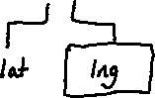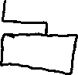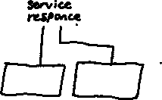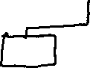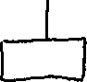

12. What tags have *attributes*?

a. album, released, track, track

13. For each tag with attributes, list the attribute *name* and the corresponding attribute *value*.

a. label=”Sony” date=”Oct 25, 1990” number=”1” duration=”16:29” number=”2” duration=”18:30”

14. Match each node in the tree with a line in the XML document above (draw a tree with the same layout as the given XMLTree where each node has the line number corresponding to that node).

15. Draw the node(s) in the tree that correspond to line 3 in the XML document.

16. Draw the node(s) in the tree that correspond to line 8 in the XML document.



17. What line(s) in the XML document correspond to the *<conductor>* node?

a. Line 4

18. What line(s) in the XML document correspond to the *<tracks>* node?

a. Lines 6 to 9

19. What’s the only *tag* node that is a leaf in the *XMLTree*?

a. <released>

20. What is child 3 of *<album>*?

a. <released>

21. What is child 0 of *<tracks>*?

a. <track> (Rhapsody in Blue)

22. What is child 1 of *<composer>*?

a. N/A

23. Draw the nodes on a path from the root of the tree to this node.



24. For each of the nodes on this path (except for the root), what is the integer index of the node as a child of its parent?

a. <tracks> = 4

b. <track> = 1

25. Draw the nodes in the *XMLTree* that would have to be modified to include this new information.

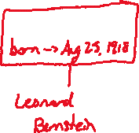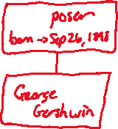

26. Rewrite line 5 in the XML document above to show the result of this change.

a. <released>Oct 25, 1990</released>

27. Draw the nodes in the *XMLTree* that would have to be modified to reflect this change in the XML document.



28. Draw the complete *XMLTree* corresponding to this document.

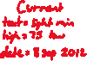

29. Change the structure of the XML document to put the *<city>* element inside the *<state>*  element. What essentially arbitrary decision did you make when doing this? Redraw the part of the *XMLTree* that is changed by this modification, taking care to match the document with respect to the decision just mentioned.

a. <state city=”Columbus”>OH</state>

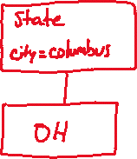

1. What is the root node?

a. <query>

1. How many attributes does the root tag have?

a. 4

1. What is the value of the yahoo:lang attribute of the root tag?

a. en-US

1. How many children does the root node have?

a. 1

1. How many children does the <results> node have?

a. 1

1. How many children does the <channel> node have?

a. 13

1. What is the range of indices of the children of the <channel> node?

a. 0 - 12

1. What is the index of the <yweather:location> child of the <channel> node?

a. 7

1. What are the names and values of the attributes of the <yweather:location> tag?

a. country->United States

b. city->Columbus

c. xmlns:yweather-><http://xml.weather.yahoo.com/ns/rss/1.0>

d. region->OH

1. Under the <item> child of the <channel> node, find the <geo:lat> and <geo:long> tags. What are the latitude and longitude of your chosen location?

a. lat = 39.98914

b. long = -82.985329

1. For both the latitude and longitude text nodes give the list of indices of the path from the root to the corresponding text node.

a. <query> [0] -> <results> [0] -> <channel> [0] -> <item> [12] -> <geo:lat> [1]

b. <query> [0] -> <results> [0] -> <channel> [0] -> <item> [12] -> <geo:long> [2]

1. Under the <item> child of the <channel> node, find the node with the forecast for *January 31 2017*. What is the label of this node?

a. <yweather:forecast>

1. What is the index of this node as a child of the <item> node?

a. 7

1. What are the names and values of the attributes of this node (i.e., what is the weather forecast for that day)?

a. date→31 Jan 2017

b. high→41

c. code→28

d. low→31

e. xmlns:yweather→http://xml.weather.yahoo.com/ns/rss/1.0

f. text→Mostly Cloudy

g. day→Tue

1. What is the height of the tree?

a. 5

1. List the nodes on a longest path from the root to a leaf (i.e., a path of length equal to the height of the tree).

a. <query> <results> <channel> <item> <title>

1. For each of the nodes on this path (except for the root), what is the integer index of the node as a child of its parent?

a. root, 0, 0, 12, 0